Title: | Window lifter with scheduler  SW Component < windlif_sch 1.0 >

History
Issue status  (Index) | Maturity/Date  (draft/invalid/valid)  (dd-mmm-yyyy) | Author  Department | Check/Release  Department | Description
1.0 | Draft  16-nov-15 | FRANCISCO QUIRARTE | DAVID DIAZ | Creation of the document.
History
Issue status  (Index) | Maturity/Date  (draft/invalid/valid)  (dd-mmm-yyyy) | Author  Department | Check/Release  Department | Description
2.0 | Draft  16-nov-15 | Francisco Quirarte y  David Díaz | Francisco Quirarte | Added: Purpose, Definitions and abbreviations.
History
Issue status  (Index) | Maturity/Date  (draft/invalid/valid)  (dd-mmm-yyyy) | Author  Department | Check/Release  Department | Description
3.0 | Draft  30-0ct-15 | Francisco Quirarte y  David Díaz | Francisco Quirarte | Added: Realization constraints and targets.
History
Issue status  (Index) | Maturity/Date  (draft/invalid/valid)  (dd-mmm-yyyy) | Author  Department | Check/Release  Department | Description
4.0 | Draft  31-0ct-15 | Francisco Quirarte y  David Díaz | Francisco Quirarte | Added: SW Conceptual design.

History
Issue status  (Index) | Maturity/Date  (draft/invalid/valid)  (dd-mmm-yyyy) | Author  Department | Check/Release  Department | Description
5.0 | Draft  1-Nov-15 | Francisco Quirarte y  David Díaz | Francisco Quirarte | Added: SW Component internal breakdown.

History
Issue status  (Index) | Maturity/Date  (draft/invalid/valid)  (dd-mmm-yyyy) | Author  Department | Check/Release  Department | Description
1.0 | Draft  16-nov-15 | FRANCISCO QUIRARTE | DAVID DIAZ | Creation of the document.

History
Issue status  (Index) | Maturity/Date  (draft/invalid/valid)  (dd-mmm-yyyy) | Author  Department | Check/Release  Department | Description
6.0 | Release  1-Nov-15 | Francisco Quirarte y  David Díaz | Francisco Quirarte | Review of

Table of Contents
1 Purpose 4
2 Definitions and abbreviations 4
3 Realization constraints and targets 4
4 SW Conceptual design 4
4.1 – Deployment Diagram 5
4.2 – Use Case Diagram 5
4.3 – Component Diagram 5
4.4 State machine diagram 6
5 SW Component internal breakdown 6
5.1 CLASS Diagram 7
5.2 Function void button_validation (void) 8
5.3 Automatic_up(void) 9
5.4 Automatic_down(void) 10
5.5 Manual_up(void) 11
5.6 Manual_down(void) 12
5.7 Anti_Pinch(void) 13
5.8 Lock_WL(void) 13

Purpose
This document has been created to explain how the window lifter works. The desired Window Lifter has to control the movement of a car’s window. It has too different movements (Up/Down) and an Anti-Pinch system, which allows controlling the way the windows behave when it finds an obstacle.

Window lifter is a module that controlees the movement of a window. The module works with two switches that indicate the direction of the movement.

The window will be emulated using a 10 led bar. The time between each transition shall be 400 msec. Each window movement has to be indicated trough a led color. Depending on movement each led has to be turn on: UP-BLUE DOWN-GREEN.

In order to consider a validate button press; the button has to be pressed at least 10 msec. The module has to be able to detect fail button press. In case the button is pressed less than 10 msec or a button combination it will to be considered as invalid.

The module will have an antipinch function that will be emulated with a push button. This signal just can be considered as valid when the movement is UP. If this signal is valid then the module has to stop the UP Movement and then DOWN the window until the window get totally OPEN. After window is totally OPEN the module has to ignore during 5 seconds all button press. After this time the module has to recognize every button press.

Definitions and abbreviations
Definitions
Acronym | Definition
config_timer(); | Initializes and configures the timers.
initModesAndClock(); | Initializes and configures the interruptions.
INTC_InstallINTCInterruptHandler(led_azul,30,1); | When a button its pressed the interruption goes to the next value, calls the vector number 30 and calls the function void led_azul().
void led_azul(void); | Principal Function where its decided what rutine will be executed by the leds.
msec | Mili second
Window lifter | It is a system that controls the movement (up and down) of the car window.
antipinch | It is a system that stop the movement of the window when it detects an object or a body part while the window is going up.
count | Counter
Sw | Switch
validpress | Validate the press of the button

Abbreviations

Acronym | Definition
STM | System Timer Module
GPIO | General Purpose Input Output
CRT | Conversion Timing registers
IPM | Input Period Measurement
CIR | Channel Interrupt Register
SIUL | System Integration Unit Lite
STM CMP | STM Compare Register

References

N° | Document name | Reference
1 | Traceability Matrix Template.xls
2 | MPC5604B/C Microcontroller Reference Manual.pdf
3 | Test_template.xls
4 | http://www.freescale.com/products/power-architecture-processors/mpc5xxx-5xxx-32-bit-mcus/mpc56xx-mcus/mpc5606b-startertrak-development-kit:TRK-MPC5606B
5 | http://www.freescale.com/products/power-architecture-processors/mpc5xxx-5xxx-32-bit-mcus/mpc56xx-mcus/ultra-reliable-mpc56xb-mcu-for-automotive-industrial-general-purpose:MPC560xB#pspFeatures
6 | SW_C_Code_Review_Template.docx
7 | Window-lifter-requirements.docx

Realization constraints and targets

System must ensure reliability on window behavior and security with the anti-pinch function, push buttons functions shall be much delimited in any unusual situation from ambiguous scenarios.
The constrains to accomplish this targets are the use of microcontroller freescale TRK-MPC5606B, emulation just for 10 led bar and anti-pinch function managed only by push button with scheduler control.

The system will be running in the MPC 5606B. With the following specifications:

- MPC5606B MCU in a 144LQFP package.
- On-board JTAG connection via open source OSBDM circuit using the MPC9S08JM MCU
- MCZ3390S5EK system basis chip with advanced power management and integrated CAN transceiver.
- CAN and LIN interface.
- Analog interface with potentiometer.
- High-efficiency LEDs.
- SCI serial communication interface.

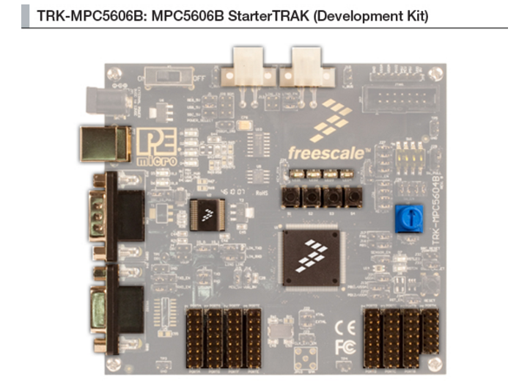

- Operating Frequency (Max): 64 MHz.
- Total DMA Channels 16.
- Internal Flash (KB): 512
- GPIOs: 149.
- EEPROM: 64 KB DataFlash®
- RAM: Up to 96 KB
- Timer: 16 bits up to 64 channels
- ADC:
- 10 bits up to 36 channels
- 12 bits up to 16 channels
- Up to six CAN
- Up to six SPI
- Up to 10 LINFlex

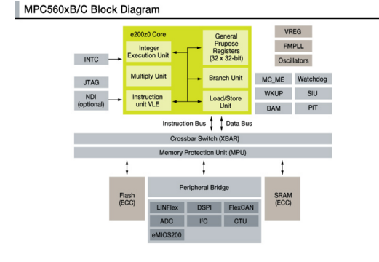

SW Conceptual design

– Deployment Diagram (A)

Are simple block diagrams, showing the physical configurations of software and hardware items. Often combined with component diagrams to illustrate which parts of the software run on which controller.

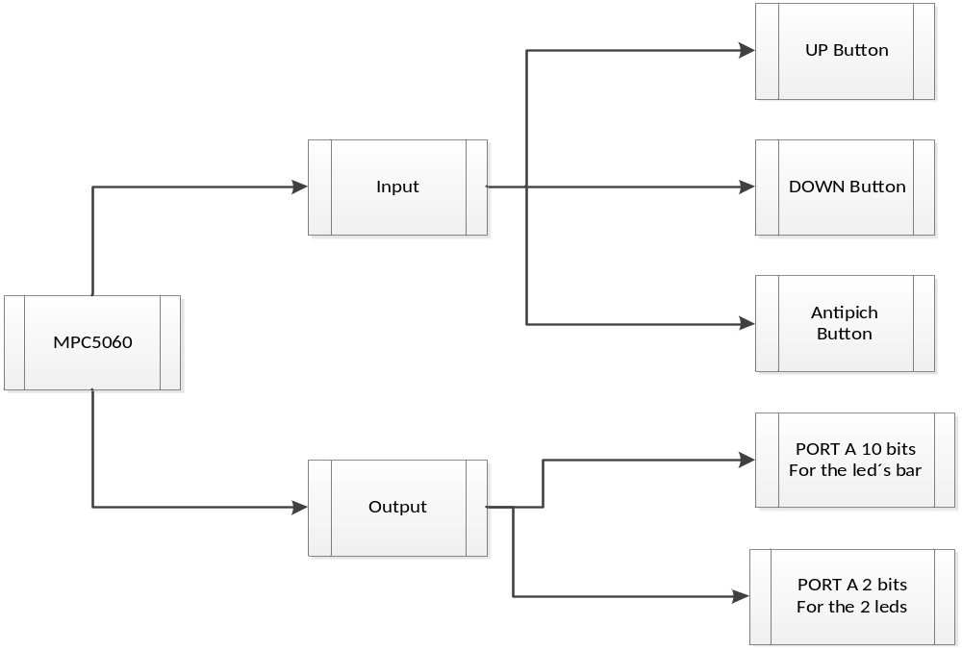

– Use Case Diagram

Diagram (a)

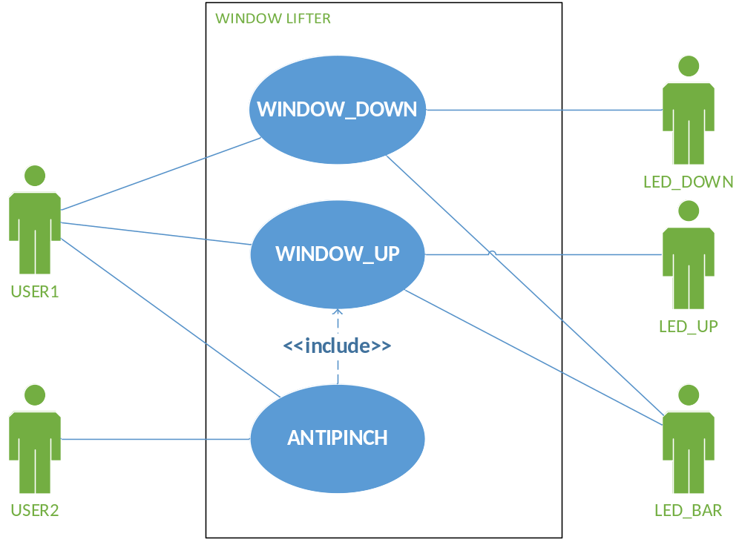

Diagram (b)

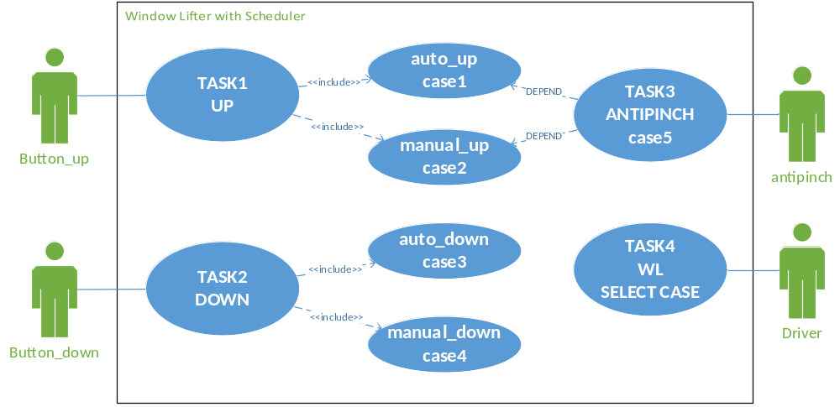

In this diagram we can see the basic interaction of human and Window Lifter system. We can see the buttons used to control the movement, the functions included in the system and the Window Lifter Application.

– Component Diagram (A/D)
Diagram (a)

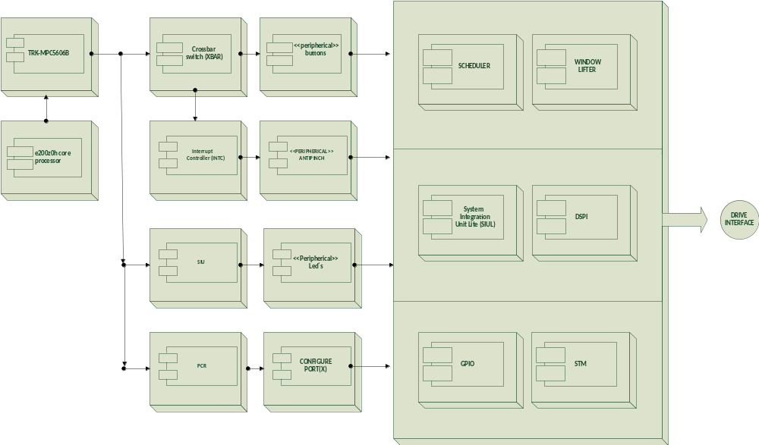

- Shows the structure of components, i.e. modular, deployable and replaceable parts of a system, subsystem or module that encapsulate implementation and expose a set of interfaces.

- Components can be organized in a hierarchical manner, i.e. a big subsystem contains a set of smaller subsystems. The smallest component in such a structure is equal to a module in the functional world.

Diagram (b)

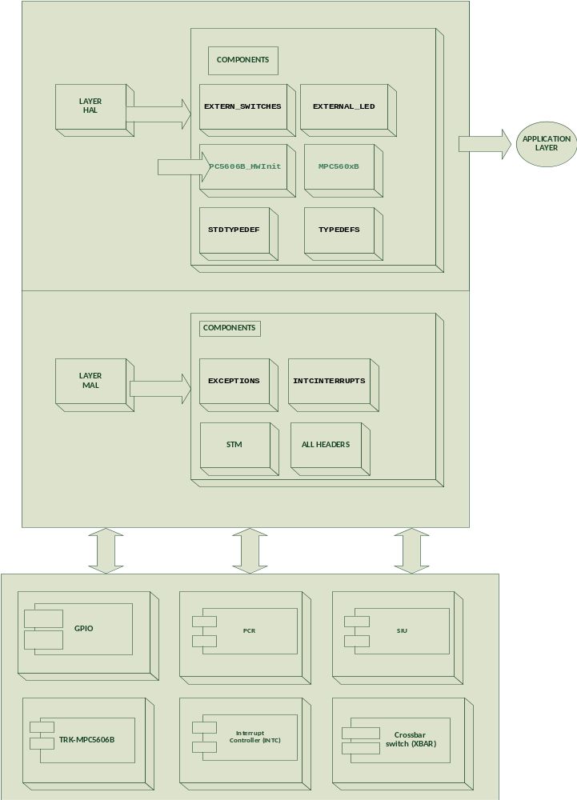

Activity Diagram (R)
- Is essentially a flowchart.

- Activity diagrams focus on the flow of activities involved in a single process and show those activities depend on one another and therefore is a good solution to describe the activities inside Use Cases.
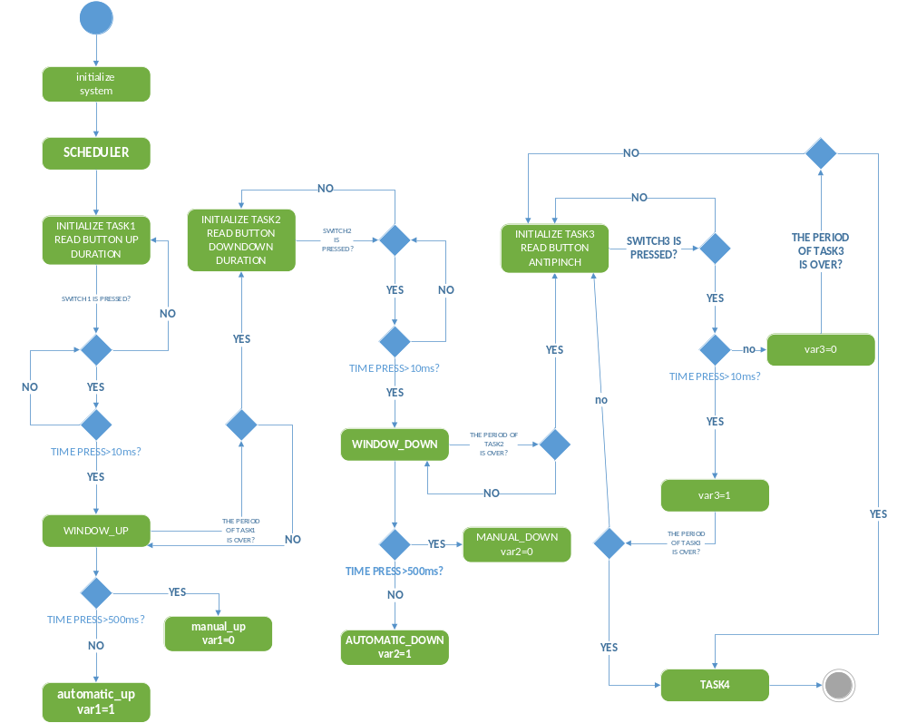

CLASS
Diagram (a)
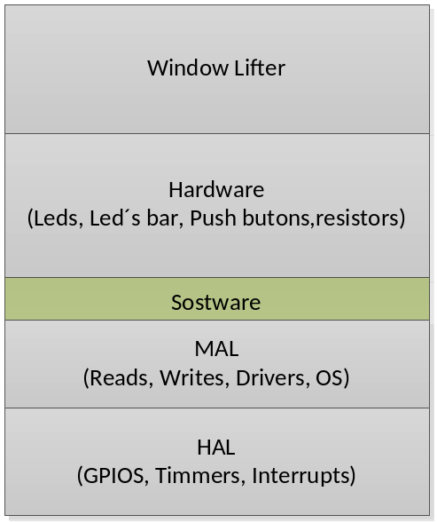

Diagram (b)

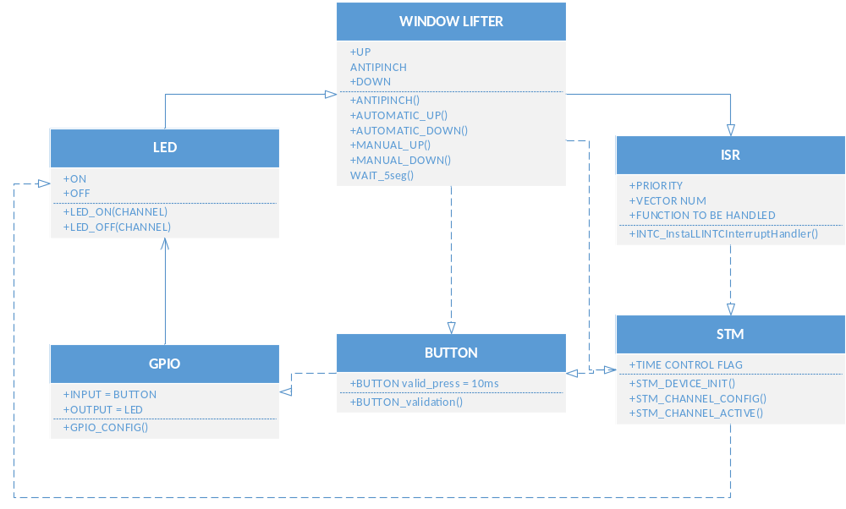

SEQUENCE
Sequence Diagram (A/D)
Describes a pattern of interaction among objects, arranged in a chronological order by "lifelines" (vertical lines) and the messages that they send to each other, by using horizontal arrows.

The time axis goes from top to bottom, and left to right.

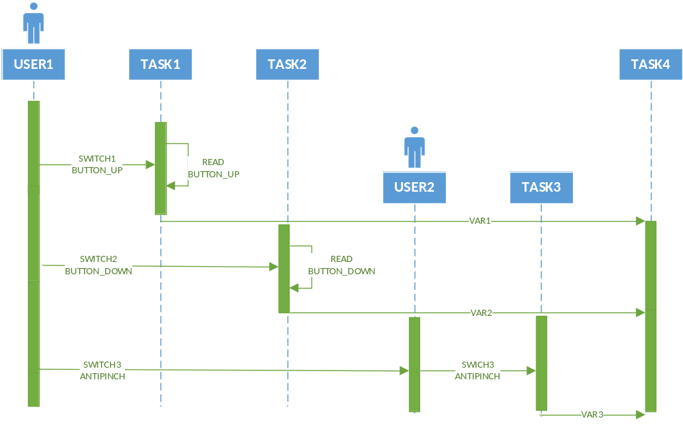

State machine diagram

Describes how the application shall works and the flow between states

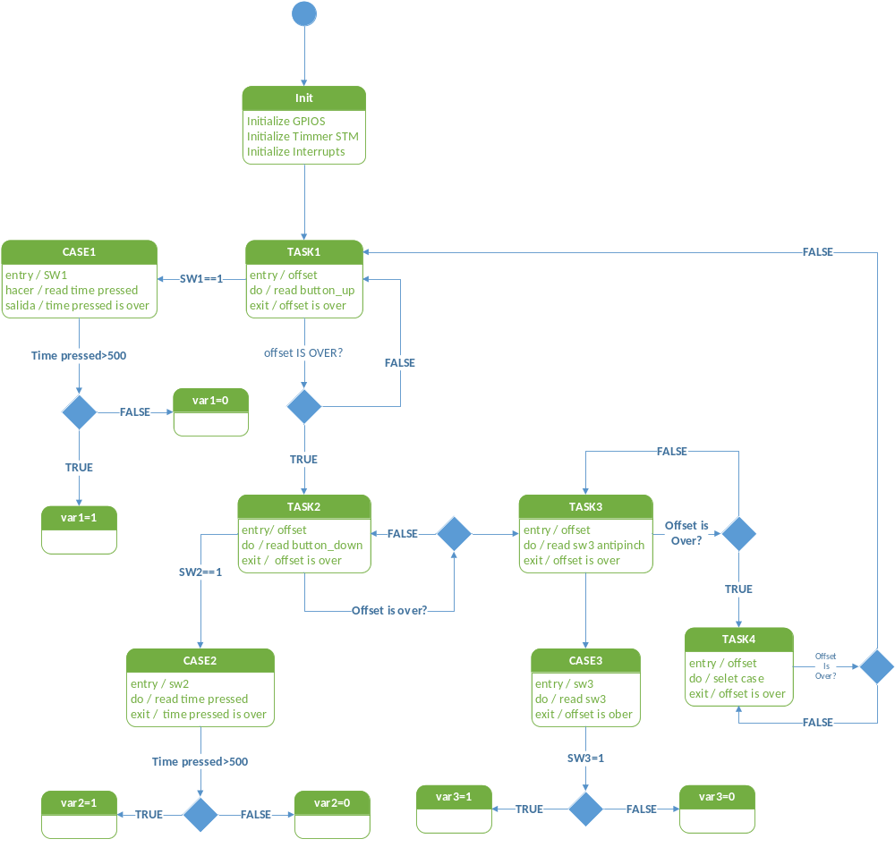

SW Component internal breakdown
Based on the above concept of the design, SW components will be managed as the following subdivided files:

GPIO: Enable and set outputs for led and inputs for push buttons

Button: Capture button signal as up or down when a time condition is accomplished, as result is the initial state from the inputs

Window lifter: When an input is captured and the state is defined by the button file, this is evaluated with the state machine contained into the window lifter file, also here is where the states are stablished with the conditions based on customer requirements

- A header which contains all the software to perform the main system was used the name of this header is DRIVERS.h.
- I will use a header called config_timer.h which contains initialization of the timer STM of the microcontroller.
- I will use a header called Pb.h which contains initialization of PLL and reading the buttons and the frequency at which they will be working.
- I will use a header called Port_config.h which contains initialization of the Configure the portA and Switches.
- I will use a header called stdtypedef.h which contains Public type header file for the coreHAL.
- It was created three global variables which are: interrupt,validar_Pb and count_Pb.
- The variable interrupt habe the task of turn on the leds with steps of 400ms.
- The variable validar_Pb habe the task of enable the function “Pb_up_auto” this function enable the requirement of turn on the ten leds in the led bar simulating the sequence up in automatic.
- The variable count_Pb habe the task of increase a counter to know the position of the time flag in 10ms of stm timer.
- The function “initModesAndClock” habe the task of initialization yhe frecuence of the microcontroller.
- Inside of the function “Principal_function” we have the function “Pb_up_auto”, “Pb_Down”, “interruption” and “condición_para_pb_up_auto”.

Functional Decomposition
- Read button Up duration: this requirement have the task decide among which the function is activated function up one touch or the function function up manual.
- Function Up one touch: this function has the task of turn on the leds by steps of 400ms in automatic.
- Function up manual: this function has the task of turn on the led bar while the push button up is pressed for more of 500ms.
- Antipinch signal: this function turn off the led’s on the led bar if the antipinch button is pressed the led bar simulating the led bar turn off one by one in steps of 400ms.
- Read button down duration: this requirement has the task to decide whether if the function is activated function read button down duration.
- Read button down duration: this requirement have the task decide among which the function is activated function down one touch or function down manual.
- Button down one touch: this function have the task of turn off the leds by steps of 400ms in automatic.
- Function down manual: this function has the task of turn off the led bar while the push button up is pressed for more of 500ms.

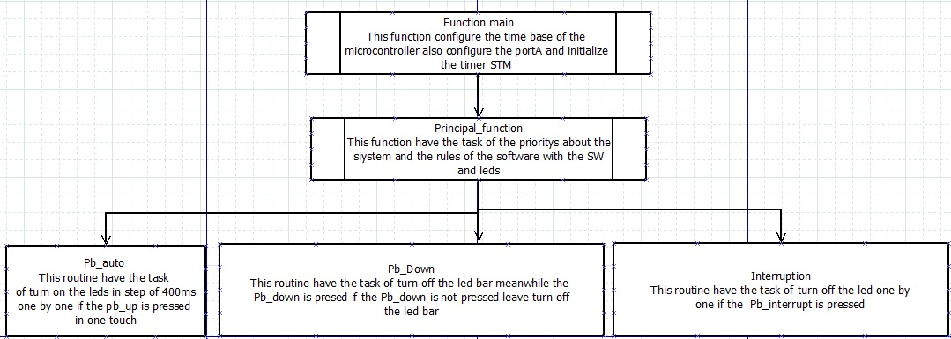

File name descriptions

File Name | Description
Tasks.c | Provides the timed task definitions
Tasks.h | Export the timed task interfaces to the scheduler configuration file
Exceptions.c | Setup of IVPR to point to the EXCEPTION HANDLERS memory area defined in the linker command file.
Exceptions.h | Export the Exception handlers to scheduler module
Timer.c | Configurate the STM timer initialization and configurate the STM flag in 1 ms
Timer.h | Export the STM flag and rise the tickflag each 1 millisecond
Leds.c | Configured the PORTA as outputs and led1 to led4 on board
Leds.h | Export the configuration of porta and led1 to led4 on board
Typedesfs.h | This file defines all of the data types for the Motorola header file
Stdtypedef.h | Public type header file for the coreHAL
INIT.c | Initialise PLL before turning it on
INIT.h | Export the pll configuration
IntcInterrupts.c | Contains an implementations of generic interrupt controller handling routines for the MPC56xx and PX MCU families
IntcInterrupts.h | Export the interface of interrupt controller handing
Kernel.h | Contain all headers implemented in the system

Api specification

Name: | Taskmasktype
Range: | tickflag | Mask_1ms | OxFA00 | Mask required for 1 ms task
 | task1 | Mask_1ms |  | Mask required for 1 ms task
 | task2 | Mask_3ms |  | Mask required for 3 ms task
 | Task3 | Mask_5ms |  | Mask required for 5 ms task
 | task4 | Mask_17ms |  | Mask required for 17 ms task
Description | The mask values to generate the task offset

Schmodule_configType
Name: | Scheduler
Type: | u8
Range: | n.a. | Structure to hold the module's configuration set. The Contents of this data structure are implementation specific
Description: | Counter tasks trought the tickflag

Name: | S_TASKS
Type: | structure
Range: | Implementation specific structure | Structure to hold the module’s configuration set. The contents of this data structure are implementation specific.
Description: | Configuration of members: period, offset and function of the tasks

Public Function Definitions
Public functions shall be exported in SchModule.h file and defined in SchModule.c file.

Name: | INTC_InstallINTCInterruptHandler
syntax | Void INTC_InstallINTCInterruptHandler(function, port,1)
Parameters(in/out) | Function type | handlerFn
Parameter2(in/out) | Port(N) | unsigned short vectorNum Configuration of required port of the board
Parameter3(in/out) |  | unsigned char psrPriority
Description: | Configuration of interrupts handler

DESCRIPTION: Contains an implementations of generic interrupt controller handling routines for the MPC56xx and PX MCU families.

Private Function Definitions
Private functions shall be defined in SchModule.c file.

Service name: | Tickflag
Syntax: | Void tickflag(  Void  )
Parameters(in/out) | None
Parameters(in/out) | None
Returns value: | None
Description: | Callback function periodically called from the timer module providing the tick reference

Service name: | STM_config_clock
Syntax: | Void STM_config_clock (  Void  )
Parameters(in/out) | None
Parameters(in/out) | None
Returns value: | None
Description: | Configure the STM flag at 1ms and initialize the counter

Name: | Tareas
Type: | Enum
Range: | Implementation specific enum | enum to hold the module’s configuration set. The contents of this data structure are implementation specific.
Location: | Tasks.h
Description: | add the number of tasks

Function void valid_press (void)

Description | In this function is detected which button is pressed, and the time it is pressed. This make the system go to the desired state (UP/DOWN)
Parameter 1 | Button UP or Button DOWN pressed
Return Value | State
Precondition | Buttons must be pressed at least 10 ms
Post condition
Error Conditions

Automatic_up(void)

Description | This function contains the automatic up movement performed by the window
Parameter 1 | void
Return Value | void
Precondition | Press some valid button.
Post condition
Error Conditions

Dynamic Behavior

In this function, the window moves automatically up. The system enters this function when the function Button_Validation(void) detects a valid button press and meets the requirements for automatic mode.

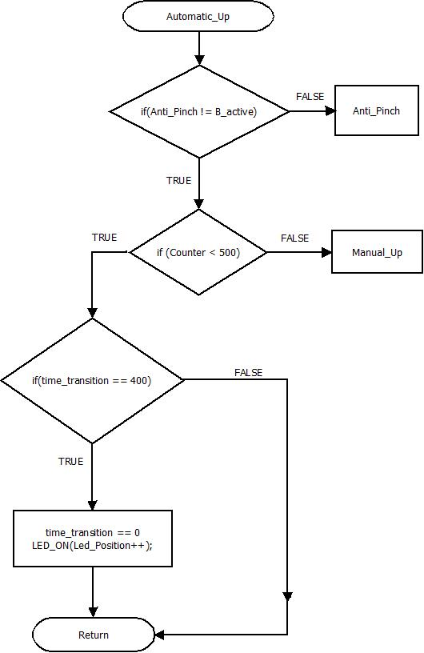

Automatic_down(void)

Description | This function contains the automatic down movement performed by the window
Parameter 1 | void
Return Value | void
Precondition | Press some valid button.
Post condition
Error Conditions

Dynamic Behavior

In this function, the window moves automatically down. The system enters this function when the function valid_press(void) detects a valid button press and meets the requirements for automatic mode.

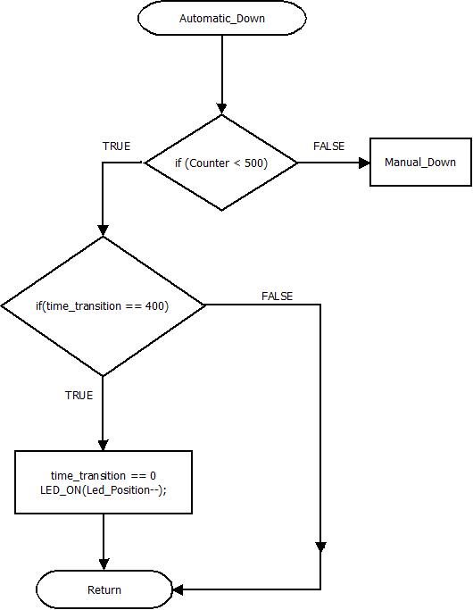

Manual_up(void)

Description | This function contains the manual up movement performed by the window
Parameter 1 | void
Return Value | void
Precondition | Press some valid button.
Post condition
Error Conditions

Dynamic Behavior

In this function, the window moves manually up. The system enters this function when the function Button_Validation(void) detects a valid button press and meets the requirements needed for manual mode.

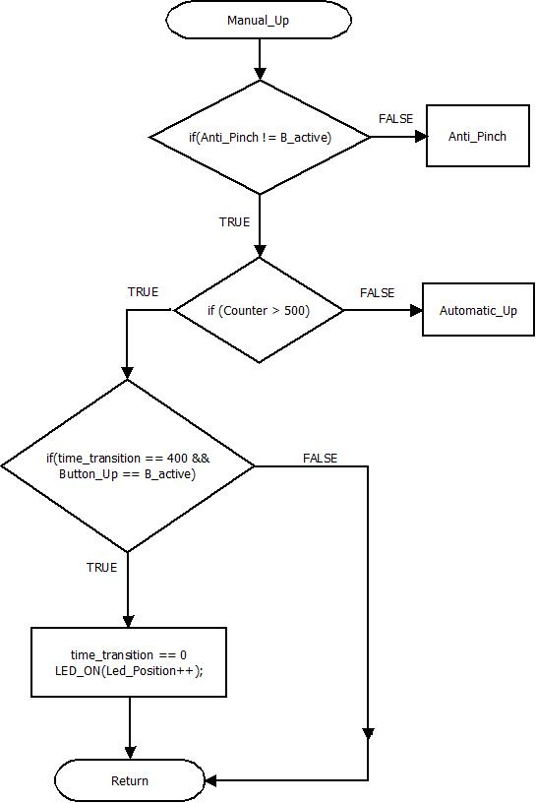

Manual_down(void)

Description | This function contains the manual down movement performed by the window
Parameter 1 | void
Return Value | void
Precondition | Press some valid button.
Post condition
Error Conditions

Dynamic Behavior

In this function, the window moves manually down. The system enters this function when the function Button_Validation(void) detects a valid button press and meets the requirements needed for manual mode.

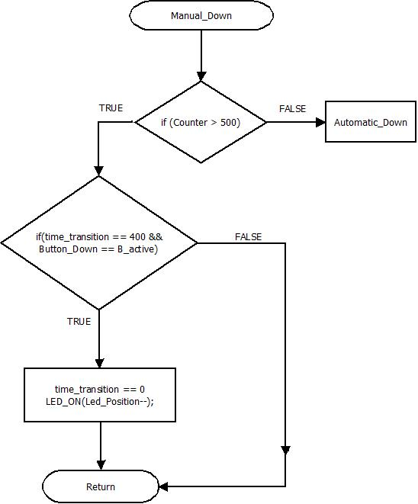

AntiPinch(void)

Description | This function cheks if there’s a button pressed representing an obstacle for the window.
Parameter 1 | Button_Up pressed
Return Value | Void
Precondition | Press some valid button.
Post condition
Error Conditions

Dynamic Behavior

This function is a safety function. It is responsible of opening the window when an obstacle is detected.

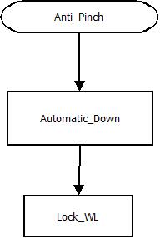

Lock_WL(void)

Description | This function blocks the system for 5 seconds
Parameter 1 | Anti_Pinch () active
Return Value | void
Precondition | Anti_Pinch detected
Post condition
Error Conditions

Dynamic Behavior

This function blocks all the system for five seconds in order to reorganize it.

